P6: Plan an E‐Commerce Strategy

You have been asked to present an e‐commerce strategy for a fictional business Tick Tock. The plan should include ideas for promoting the site, what costs will be involved (actual figures are not required), the security measures to be put in place and how the site will be hosted. You must cover the following points:

- E‐commerce strategy: structure of site; hosting; promotion; issues e.g. cost, security
- Structure: customer interface e.g. ease of use, display of products, personal details entry, credit card entry, other types of payment, delivery details; image; style
- Hosting: choice of ISP; in house or sub‐contracted
- Promotion: marketing e.g. advertising the site, placing in search engines; message board; chat rooms
- Costs: setup; maintenance; security; leasing; advertising; delivery strategy; staff training
- Security: fraud protection; hackers; viruses

E‐commerce Strategy for ‘________’

E‐commerce Consultant: | [Enter your name here]
Date: | [ Enter Today’s date]

Structure of Site

Draw a tree diagram here to show the structure of the e‐commerce website

Customer Interface

Paste the screen‐prints of your e‐commerce interface here which includes:

‐ Homepage
‐ One other page of your choice
‐ Checkout page (where customer’s input their personal and payment details)

Annotate each screen‐print with the following to give the management at Trends a feel of their e‐commerce website:

‐ Company image i.e. logo
‐ House style: e.g. Colour Scheme, font sizes and styles
‐ Where the navigation has been placed and why
‐ Ease of use – how have you made the interface easy to use for the customer?
‐ Shopping basket
‐ Search Bar
‐ Any other design features used

Hosting

Internet Service Provider

‐ Which company will provide your Internet? Complete the table to compare the ‘Broadband Packages of each
Internet Service Provider:

Internet Service Provider | Broadband Speed | Package features | Monthly Price

‐ Who have you selected as the internet server provider? And why?

‐ In house hosting

This means that the website will be run from a webs server within the company and managed by staff with the necessary
technical skills to work with websites within the company. You will need to find out about how much it will cost to register a domain name. Find out four different domain name registrars and compare their costs. Here you are buying just the domain name and not web server space or e‐mail addresses.

Domain name registration company | Price (per month or year)

‐ Who have you selected and why?

Web Hosting

‐ Sub‐contracted web hosting

This means that the business will pay another company to create and host the website. Find out how much it would cost to sub‐contract the website to a ‘web hosting company’ that will offer both web server space as well as e‐mail
addresses and domain names.

Domain name registration  company | Web space | Package features | Price (per month or year)

‐ Decide whether the e‐commerce website will be hosted in house or sub‐contracted? Explain your choice.

PROMOTION

Recommend methods of promoting the e‐commerce website for trends. Explain the potential advantages & disadvantages of your chosen methods. Refer to your work on M1.

Examples of methods of promotion:

- Placing in search engines
- paying for prominence in search result listing
- newsgroups and forums
- chat rooms
- banners and pop‐ups
- Spam
- Direct marketing;

Costs

• Setup
o If the website is being hosted in house – how much will it cost to purchase the servers, server software and domain name?
o If the website is being subcontracted, how much will it cost?

• Maintenance
o Once the e‐commerce website has been set‐up, who will maintain it? In – house or an outside agency? How much will it cost to employee somebody inside? (Find out the hourly rate to employ web developers).
o How much would it cost to employ an outside agency to maintain the website?

• Security
o How much will it cost to buy the security software?
o How will customers know that the e‐commerce website will protect their personal and financial
information?

• Advertising
o How much will it cost to list the e‐commerce website in a search engine?
o How much will it cost to advertise the e‐commerce on other websites through banners or pop‐
ups?
o How much will it cost to advertise the e‐commerce website on TV or Radio?

• Delivery strategy
o How will the goods be delivered to the customers?
o Will you use courier service or royal mail?
o How much will it cost to post by royal mail (go to royal mail website)
o How much will it cost to use a courier service?
o Will you charge the customers or will you deliver for free?

• Total Costs for running the e‐commerce website
o What are the total set‐up and running costs?

Security
Recommend measures for overcoming any security concerns for ‘______’ e‐commerce website such as prevention of fraud,
hackers and viruses. Refer to your work on P3 and M2. Explain their respective advantages and disadvantages.

M3: design an interface for an e‐commerce business.

For M3, you will include a customer interface design for ‘______’. Before you do this you need to look into a range of e‐commerce interfaces.

1. Evaluate the following two e‐commerce interfaces using the checklist provided:
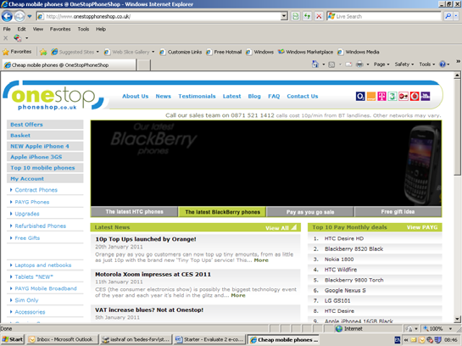

Website 1: http://www.onestopphoneshop.co.uk/ Examine the homepage and then answer the following
questions:
 | Is there a search box  facility? | Yes  No 
 | If yes, is it clearly positioned? | Yes  No 
 | Is there an option to  browse through the category of products quickly? | Yes  No 
 | Does the website have  a simple navigation bar which is suitably located? | Yes  No 
 | Is the shopping basket  clearly visible on each page? | Yes  No 
 | Does the homepage  display special offers and new arrivals? | Yes  No 
 | Is the size of the  pictures appropriate? | Yes  No 
 | Is the webpage  download speed appropriate? | Yes  No 
 | Is the content spaced  out suitably? | Yes  No 
 | Was the website easy  to use? | Yes  No 
 | Would you purchase a  phone from this website? | Yes  No 

Website 2: http://www.carphonewarehouse.com/
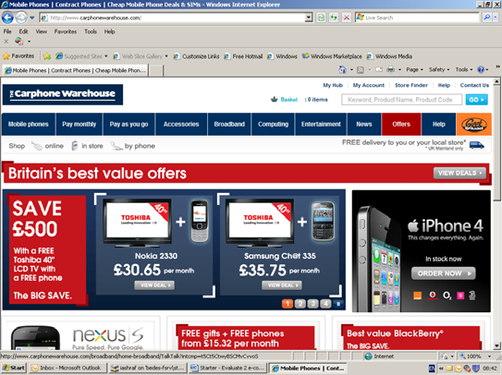 | Is there a search box  facility? | Yes  No 
 | If yes, is it clearly positioned? | Yes  No 
 | Is there an option to  browse through the category of products quickly? | Yes  No 
 | Does the website  have a simple navigation bar which is suitably located? | Yes  No 
 | Is the shopping  basket clearly visible on each page? | Yes  No 
 | Does the homepage  display special offers and new arrivals? | Yes  No 
 | Is the size of the  pictures appropriate? | Yes  No 
 | Is the webpage download speed  appropriate? | Yes  No 
 | Is the content spaced  out suitably? | Yes  No 
 | Was the website easy  to use? | Yes  No 
 | Would you purchase  a phone from this website? | Yes  No 

Which e‐commerce website would you prefer to shop at?

Website 1  Website 2 

List three design features that make your chosen website a ‘Good’ e‐commerce website.

• Feature 1:

• Feature 2:

• Feature 3:

2. Now design an e‐commerce interface for ‘_____’ in powerpoint. The designs must cover the homepage, a page of your choice and a checkout page.

 | Page 1: Homepage | Page 2: Page of your choice | Page 3: Checkout page
Is there a search box
facility?
Is it in the same place on
each page?
Is there an option to
browse through the
category of products quickly?
Does the website have a
simple navigation bar
which is suitably and consistently located on each page?
Is the shopping basket
clearly visible on each page? Is it in the same place?
Does the homepage
display special offers and new arrivals?
Is the size of the pictures
appropriate?
Is the webpage download
speed appropriate?
Is the content spaced out
suitably?
Is the interface easy to
use?
Is there use of consistent
house style?

